FRONT_PAGE

<html>

<head>

<link rel="stylesheet" href="nnn.css"/>

</head>

<body>

<img span class="s" src="n.jpg"></span></img>

<center><img class="circle" src="pic.jpg"></img></center>

<br><br><br><br><br><br>

<b><img span id="g" src="gm.jpg">nayandharviya123</span></img ><lable></lable>

<br>

<img span id="g" src="li.jpg">Nayan Dharviya</span></img >

<br>

<img span id="g" src="fb.png">nayandharviya</span></img>

<br>

<img span id="g" src="tw.jpg">nayandharviya</span></img>

<br>

<img span id="g" src="is.jpg">+91 9890488137</span></img></b>

<center><span class="h ">Hello, I am<br><b>Nayan Gopal Dharviya</b></span>

<a class="link" href="resume.html">resume</a></center>

<p class="s1">To work in a challenging environment demanding all my skills and adapt myself in different fields for the development of the organisation with impressive performance. </p>

</body>

</html>

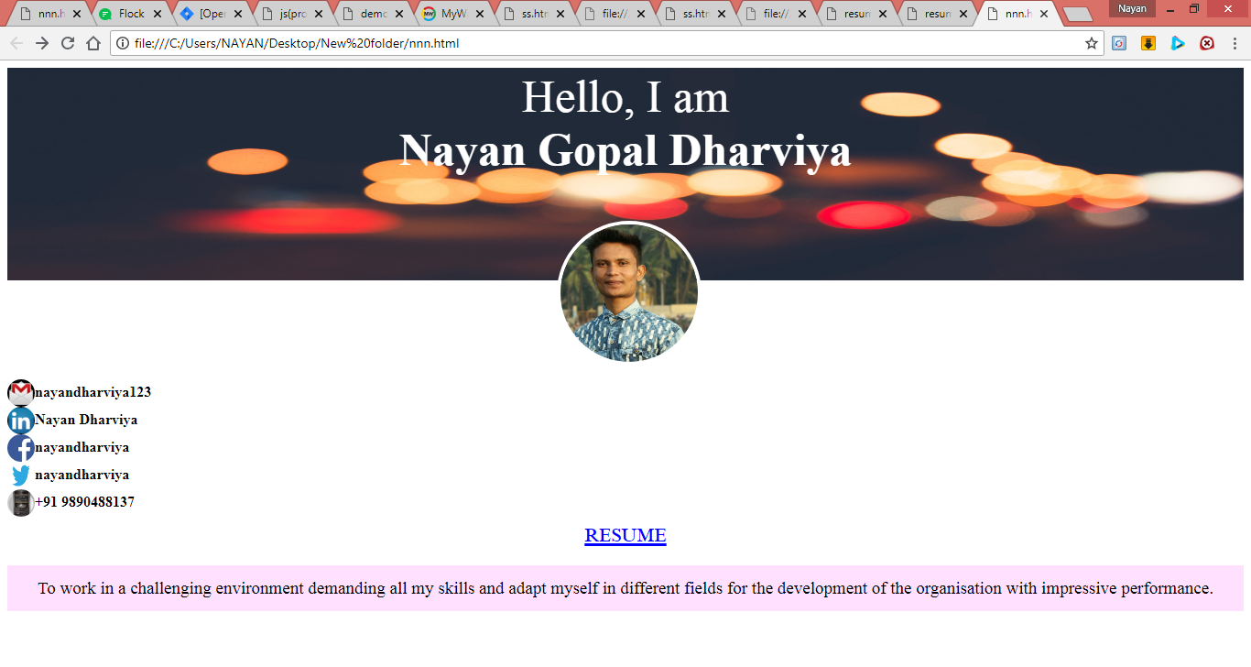

ABOUT US:

<html>

<head>

<link rel="stylesheet" href="nnn.css"/>

</head>

<body>

<center>

<h1 class="b">ABOUT ME</h1>

</center>

<br>

<br>

<b><p class="h1">Full Name </b>: Nayan Gopal Dharviya</p>

<b><p class="h1">Birth-Date </b> : Jan 23,1998</p>

<b><p class="h1">Mobile </b> : 9890488137</p>

<b><p class="h1">Address </b> : 001,Jai Gurudev Complex,Kalher,Bhiwandi-421302</p>

</body>

</html>

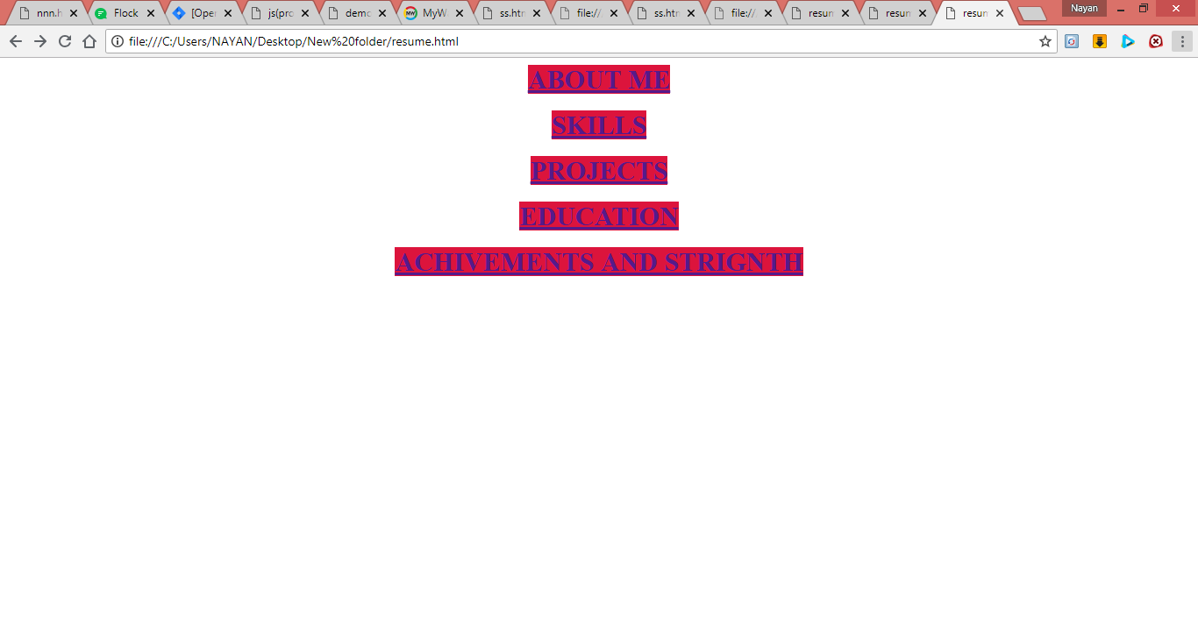

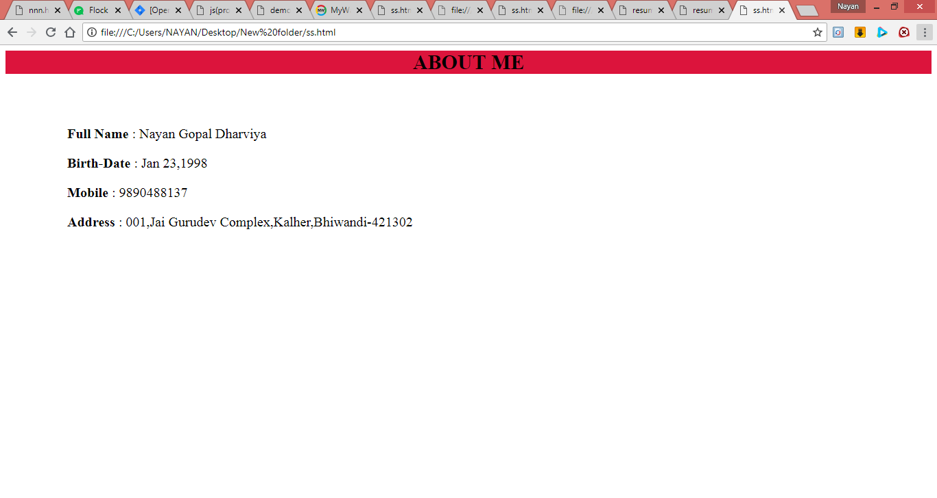

SKILLS:

<html>

<head>

<link rel="stylesheet" href="nnn.css"/>

</head>

<body>

<center>

<h1 class="b">TECHNICAL SKILLS</h1>

</center>

<ul>

<b><li>

Programming Language : C++ , Java</li><br>

<li> Operating Systems : Windows , Linux </li><br>

<li> Web Technology : HTML ,CSS , Asp.net </li><br>

<li> Database : SQL Server 2008 </li></b>

</ul>

</body>

</html>

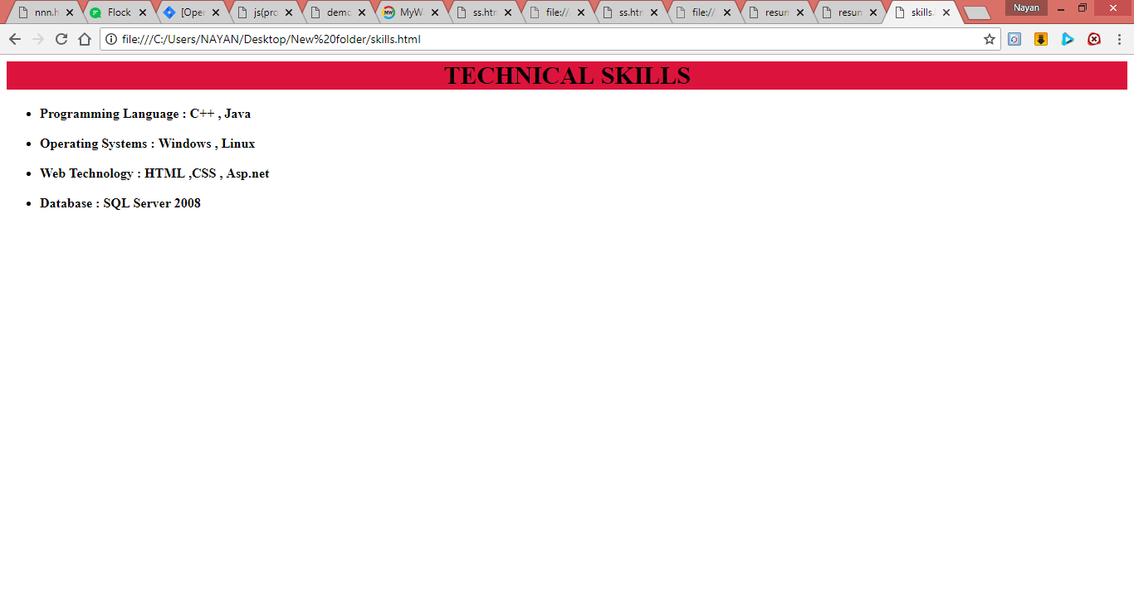

PROJECTS:

<html>

<head>

<link rel="stylesheet" href="nnn.css"/>

</head>

<body>

<center>

<h1 class="b">PROJECT</h1></center>

<ul><li><b>Title </b> : <u>GST Billing System</u> </li><br>

<b><li>Environment : </li></b><br>

<p> <b> Front-End </b> : Visual C#

<br><p><b> Back-End </b> : SQL Server 2008

<br><p><b> Team Size </b> : 2

<br><b> <p> Duration </b> : 6 months

<br><b> <p> Role </b> : Designer, Developer, Tester

<br><p> <b> Description </b> : GST Billing System is a desktop application. This System provides the Details of all Customers, Suppliers and Products. And also generates the Reports like Bill report, item wise sale/purchase report, Customer sale Report (date/month/year) wise. And it also allow the user to find GST Amount (month/year/day) wise .

<br><p><b> Objective</b>

<br><ol><li> To reduce the paper work. </li>

<br><li> To reduce the manual work. </li>

<br><li> To improve and easily maintain the business. </li>

<br><li> Accurate result can be obtained. </li></ol>

</body>

</html>

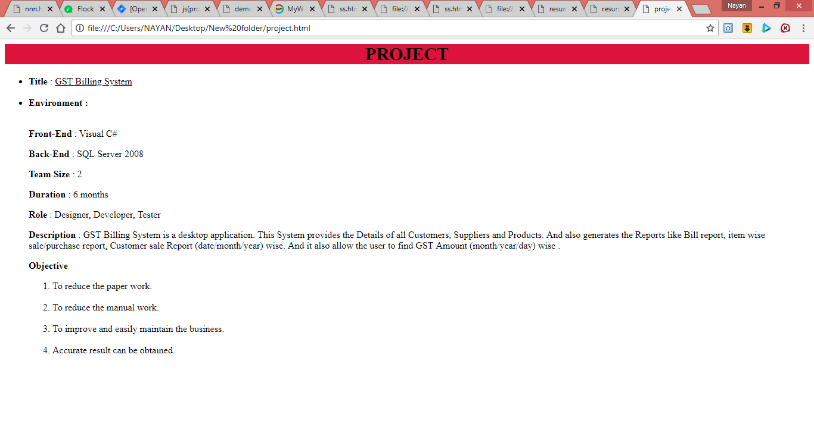

EDUCATION:

<html>

<head>

<link rel="stylesheet" href="nnn.css"/>

</head>

<body>

<center>

<h1 class="b">EDUCATION</h1>

</center>

<ul>

<b><span><li>Bachelor Degree-Information Technology</li>

<u><p>2015-2018</p>

<p>Mumbai University</p></u>

<p>i completed this degree from N.K.T.T. Clg at Thane.I successful completed all the credits without any failout and got A grade overall.</p></span>

<b><span><li>College-Science</li>

<u><p>2013-2015</p>

<p>Maharashtra State Board</p></u>

<p>i completed this degree from S.K. Somaiya college.I successful completed all the credits without any failout and got B grade overall.</p></span>

<b><span><li>School</li>

<u><p>2012</p>

<p>Maharashtra State Board</p></u>

<p>i completed this degree from S.H.V.O.V. .I successful completed all the credits without any failout and got O grade overall.</p></span>

</body>

</html>

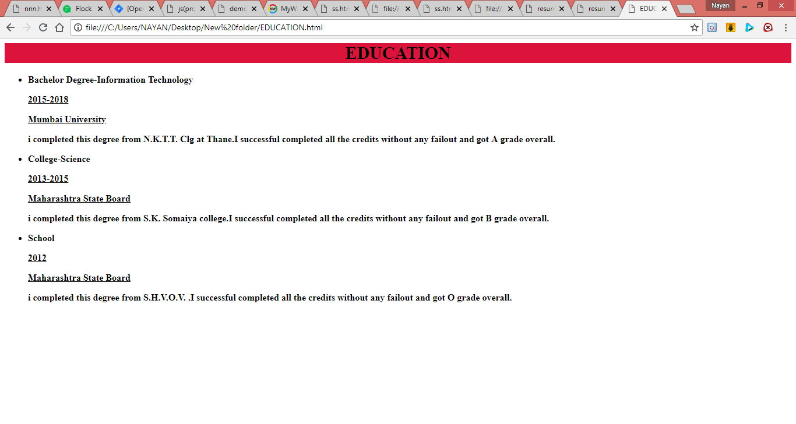

ACHIVEMENTS AND STRIGNTH:

<html>

<head>

<link rel="stylesheet" href="nnn.css"/>

</head>

<body>

<center>

<h1 class="b">ACHIVMENTS & STRENGTH </h1></center>

<b><ul>

<li> Participated in NSS and did many Social work, and complete Seven days camp. </li>

<br>

<li> Got Certificates in Sports in school.</li>

<br>

<li> Got Certificate of being topper of S.Y.B.Sc.IT class.</li>

</center>

</body>

</html>

